emuLadder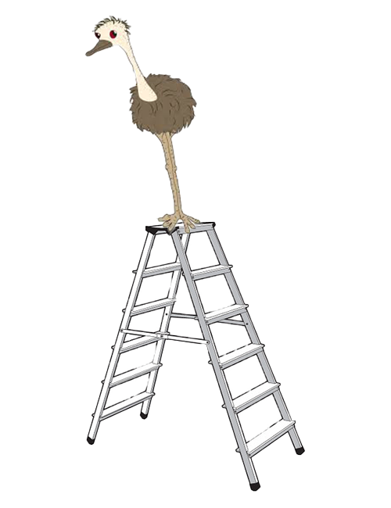

Daniel Frye, Gabriel Wilmoth, Mckenzie Moize, Rinty Chowdhury, Robert Meyer

Table of Contents

**Project Definition 2**

**Functional Requirements 2**

**Usability Requirements 2 System Requirements 3**

**Security Requirements 3**

**Project Specifications 3**

Focus Domain **3**

Libraries / Frameworks **3**

Platform **4**

Genre **4**

**System - Design Perspective 5**

Top-Down Diagram  **5**

Class Diagram **6**

Use-Case Diagram **7**

Sequence Diagram **8**

Data Flow Diagram **9**

E-R Model **10**

Wireframe Model **11-15**

**System - Analysis Perspective 16**

Data Dictionary **16-18**

Process Models **19**

Subsystem Algorithm Analysis **19-20**

Project Definition

The application, emuLadder, is a Fantasy eSports game similar to ESPN’s Fantasy Football, Hockey, etc. Users draft real-life eSports players from games such as League of Legends and compete against other users with their drafted players. Users earn points based on their drafted players stats per game. Fantasy games are very popular in sports such as football, soccer, hockey and many more, however, there is not a strong presence of Fantasy eSports. eSports is an ever-growing scene, and emuLadder seeks to provide a Fantasy experience to a community that not only enjoys eSports but also to those that enjoy video games in general. To achieve this, emuLadder looks to provide a competitive environment that keeps the user involved in both their Fantasy game and the eSports games their players are competing in.

Functional Requirements

1. The application should be able to track eSports data in real-time.
2. The user should be able to join game rooms by invitations.
3. The user should be able to create an account using his/her information.
4. Users should be able to send invitation codes to projected friends. The application should be able to see the user’s contact information and social media in order to create new friends.
5. The application should be able to track player progress and update it in real-time.
6. The application will be able to handle pseudo-money transactions between users. The user can use that virtual money to add or exchange a good player to his/her team.
7. Users should be able to host a game room.

Usability Requirements

1. Game status will be displayed to keep the user updated about the game.
2. The application will match with the real world so that the user can connect with it easily. It will make things easy for the user to play. All the game symbols and characters will be similar to real-world icons.
3. Learning and performing the game should be easy for the new user. The game buttons and icons should be self-explanatory. The game will provide help to the new user when extra help is needed.
4. Users will have some freedom to change the game settings so that the system will be more flexible and user-friendly but it will be limited. Users will be able to undo the job if they don’t want to continue with it.
5. The application will have maintenance options to prevent the system from error. It will also help the user to recognize, diagnose, and recover from bugs.
6. The application will maintain the basic game standard and feature format.
7. Users will be able to save and load their data.
8. The user can customize and personalize the game based on their choice to make the game more fun and engaging.

System Requirements

1. The system will be web-based, thus the application will be available on any machine with a web browser. Supporting the latest versions of Chrome, Firefox, Safari, Safari for iOS and Internet Explorer 9-11.
2. Basic internet connectivity.

Security Requirements

1. The system must maintain the confidentiality of all data that is classified as confidential.
   1. Passwords
   2. Emails
   3. Credit Card Information
2. The systems libraries/plugins must follow and ensure the confidentiality of login information as well as payment information.
   1. Sign-up / Sign-in plugin
   2. 3rd party payment plugin
3. Two-factor authentication to meet standard security requirements.

Project Specifications

Focus Domain

1. Our domain is online betting/drafting applications. Our focus is specifically to make an application for users interested in eSports just like the already booming Fantasy Sports applications. A specific target crowd being the exponentially growing crowd that watches eSports.

Libraries / Frameworks

1. Java backend for connecting to database and auxiliary services.
   1. SpringBoot Framework
   2. IntelliJ Development Environment
2. JavaScript auxiliary service for web scraping and API calls
   1. Node.js
   2. NodeEclipse Development Environment
3. MySQL for database services
   1. AWS Relational Database Management
   2. MySQL Workbench Development Environment
4. JavaScript for functionality of web pages
   1. Angular 8 / Typescript
   2. Visual Studio Code Development Environment
5. HTML5 / CSS3 for front end visualization and web design
   1. Visual Studio Code Development Environment
6. Amazon Web Services for website hosting
   1. AWS Console Development Environment

Platform

A web-based application for laptop, desktop, and mobile machines.

Genre

1. Web application within the genre of Strategic Simulation/Sports Management

System - Design Perspective

Top-Down Diagram

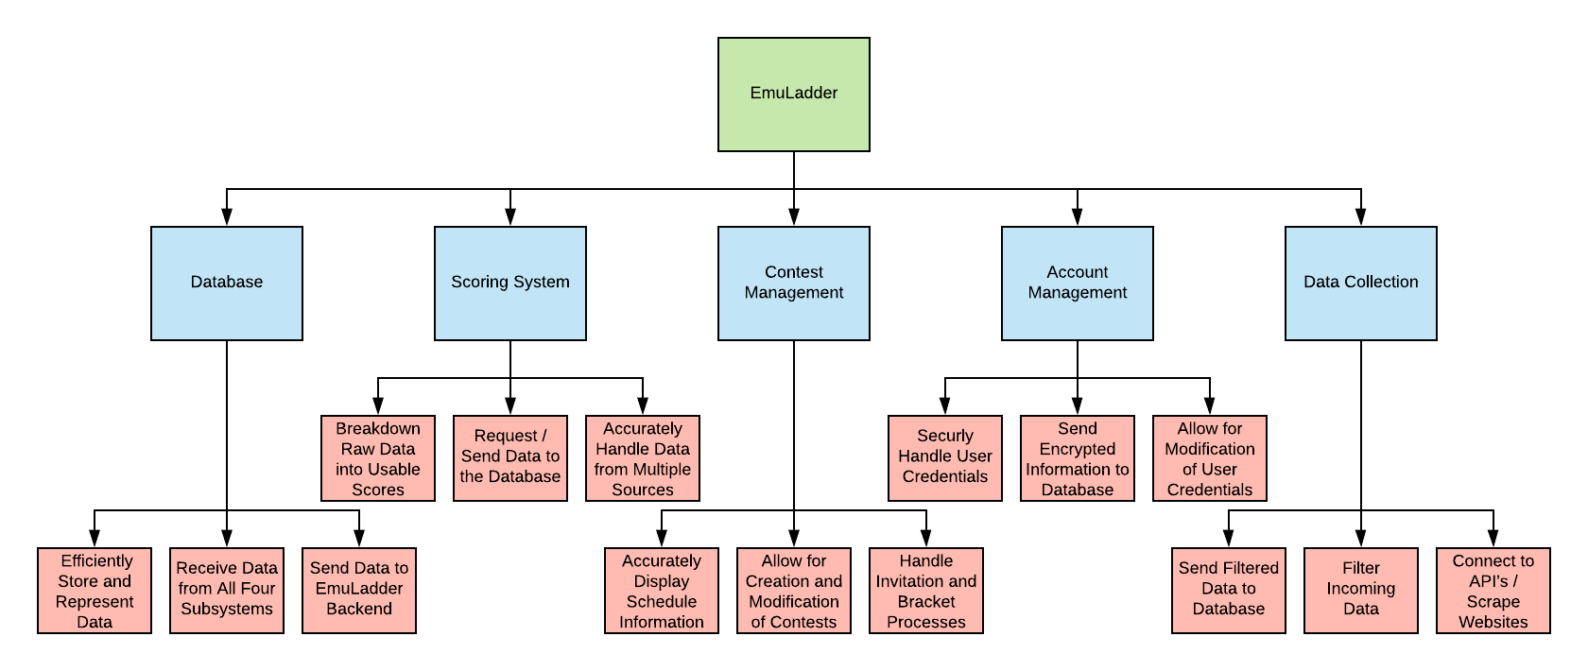

**Top-Down Diagram:**

The top-down diagram above, breaks down the project system into its lower manageable levels and their connections. In our subsystems: Database, Scoring System, Contest Management, Account Management, and Data Collection are divided into separate sub-processes that take place within each subsystem. Such as:

1. Database: Store and Represent Data, Receive Data from subsystems and Send Data to backend of the system
2. Scoring System: Process raw data ,Request and send Data to Database and Handles Data from multiple sources
3. Contest Management: Display Schedule information, Allow creation of and updates of Contests and Invitation and Bracket processes
4. Account Management: Security and user credential handling, Sends Encrypted information to Database, Allows Modification of user credentials.
5. Data Collection: Sends filtered data to Database, Filter incoming data and Connect with API(s)

Class Diagram

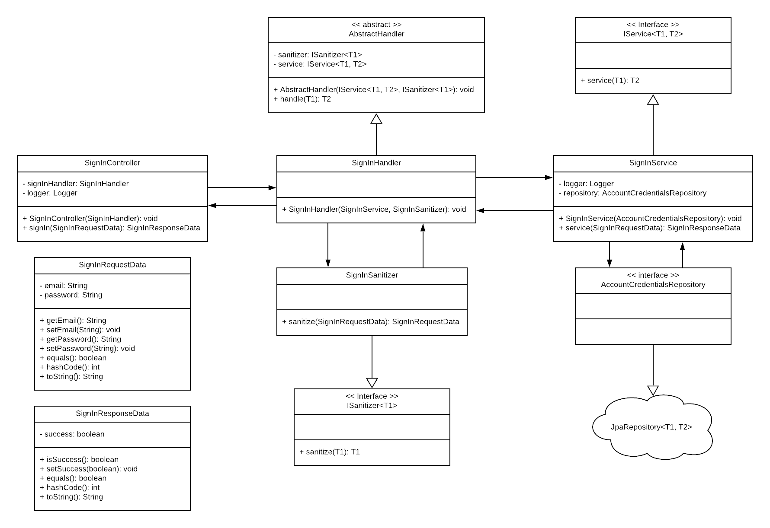

**Class Diagram:** Our backend service will utilize a MVC (Model View Controller) design pattern implemented using the SpringBoot framework in Java. This design pattern has the service exposed by a controller class (SignInController), which takes in as a parameter a request data object based on the mapped context path. The controller then passes the request data to the handler. The handler is responsible for passing the request data through a sanitizer to scrub for sanitize the input, then passing the request data along to the service. The service then performs the business logic on the request data and sends a new response data object back up through the controller and back to the initial caller. Above, I have shown how this process will work for the sign in process, but this will be used for each individual action such as editing an account, password reset, creating contests, getting contest ranking, and many, many more.

Use-Case Diagram

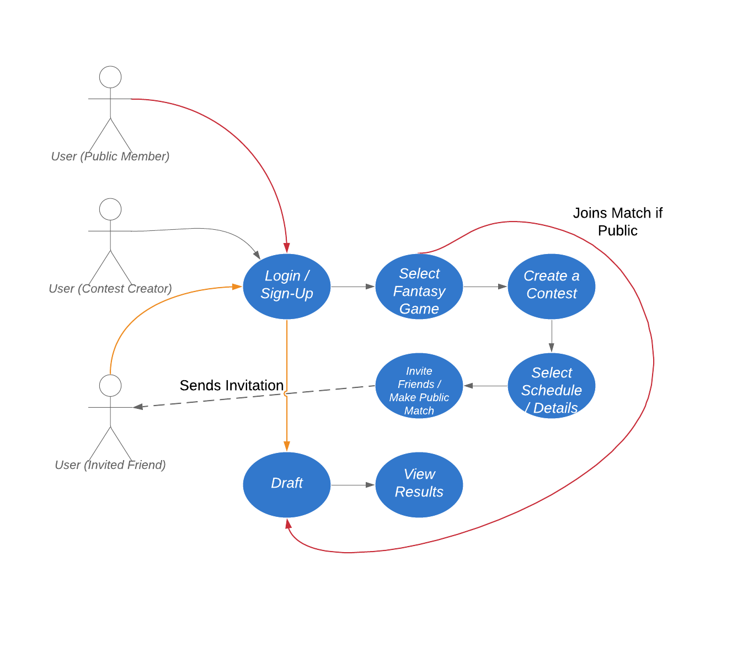**Use-Case Diagram:**

In the above Use-Case Diagram we walk through the case in which a user Signs-up or logs into a system. Then said user goes through the actions of selecting a game and creating a contest for said game. The user is then able to select a scheduled event and invite friends to the event. After the user has invited friends they will then be able to draft a team. The User (Invited Friend) goes through a similar process as in signing up for the website and then goes directly to drafting a team in the contest.

Sequence Diagram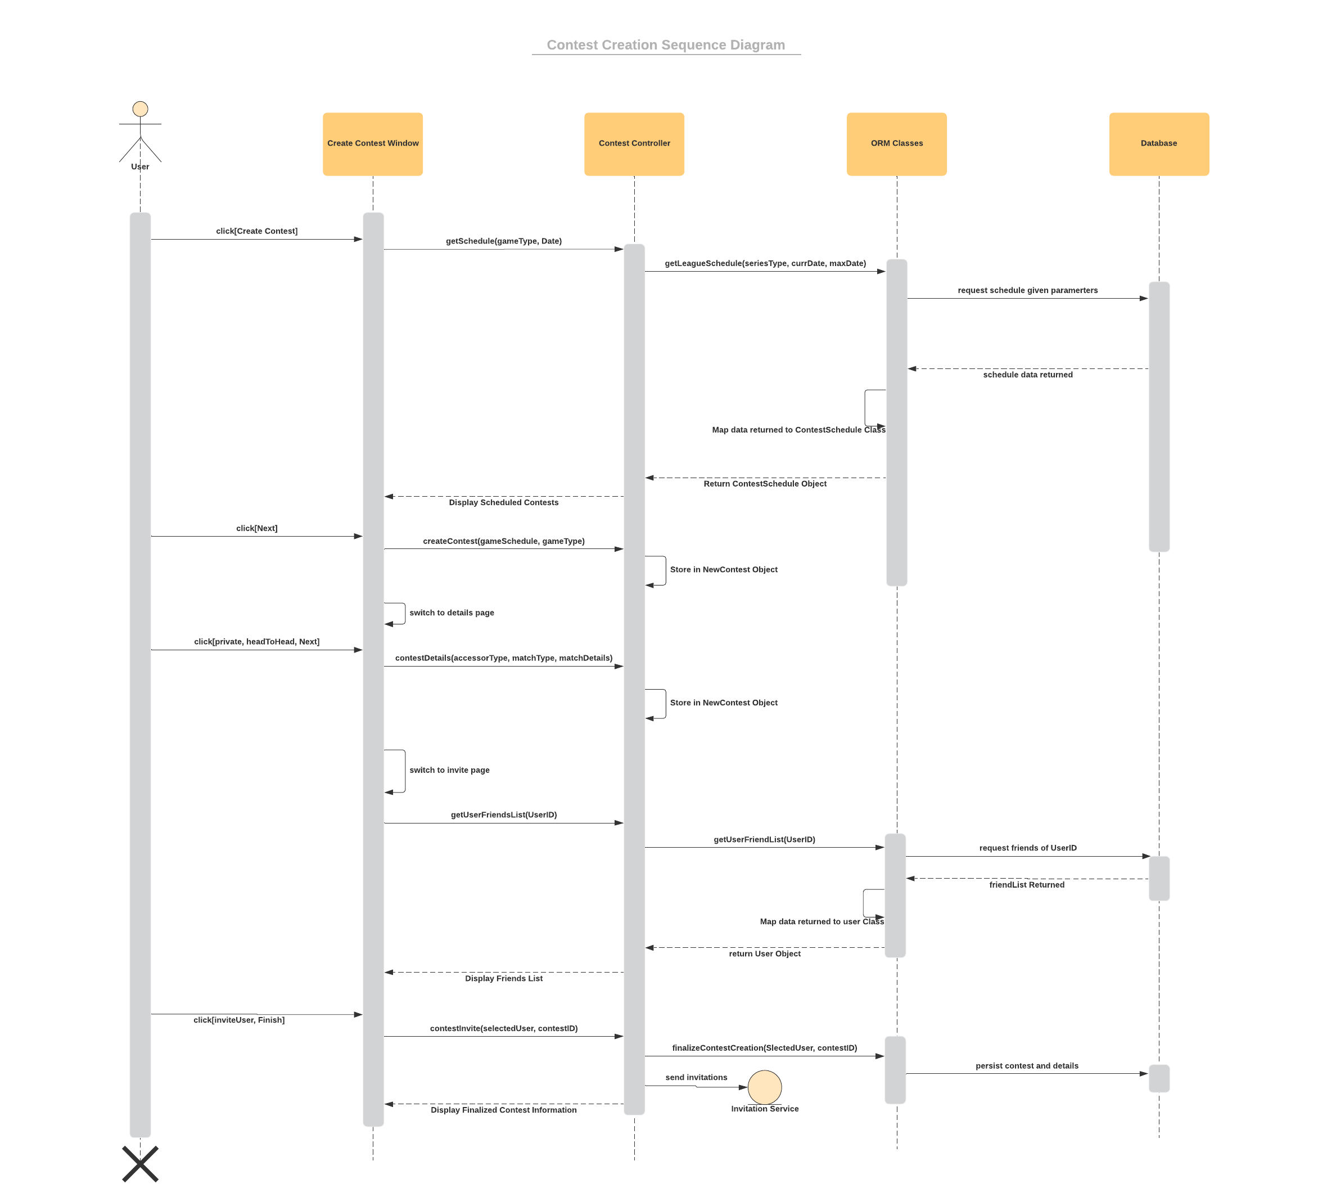

**Sequence Diagram:**

The above Sequence Diagram follows the interaction of a user creating a contest and all the behind the scene calls that will be made. It starts out with the user clicking “create a contest” on the UI and then said click calls a series of events which track all the way to the database which inevitably return the schedule for said event. After the schedule has been returned to the UI the user proceeds with a details page where they set the details for the contest and then to an invitation page where they can invite friends. Once the switch to the invite page occurs there is a call to the database again in which we load all of the users friends for an invite and that is returned to the UI. The user then selects whom they want to invite and click “finish” which will set out an invitation email as well as persist the contest information to the database.

Data Flow Diagram

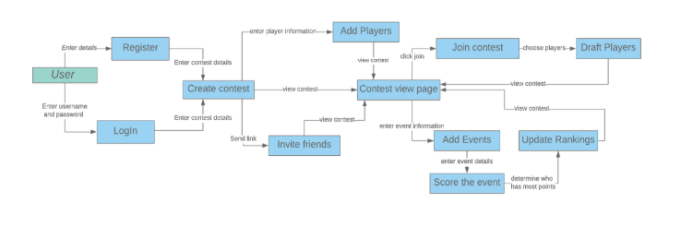

**Data Flow Diagram:** The data flow diagram demonstrates how the data is being used by our service. For instance, when a user enters their username and password, it is being used for them to login. The diagram details the type of data that is being received and where that data is being sent. It uses contest information to create contests and event information to create events. It uses data from the player list to draft players. It takes the event information to get the current score of the event then it updates the ranking of the player. In the contest view page, it displays all the updated information about the contest. It also sends links to invite friends.

E-R Model

**E-R Model:** The E-R model defines the entities within the database, as well as the relationship between them. The weak entities and relationships are specified with double lined borders. The multiplicities of the relationship are defined on the lines connecting the entities to their relationships.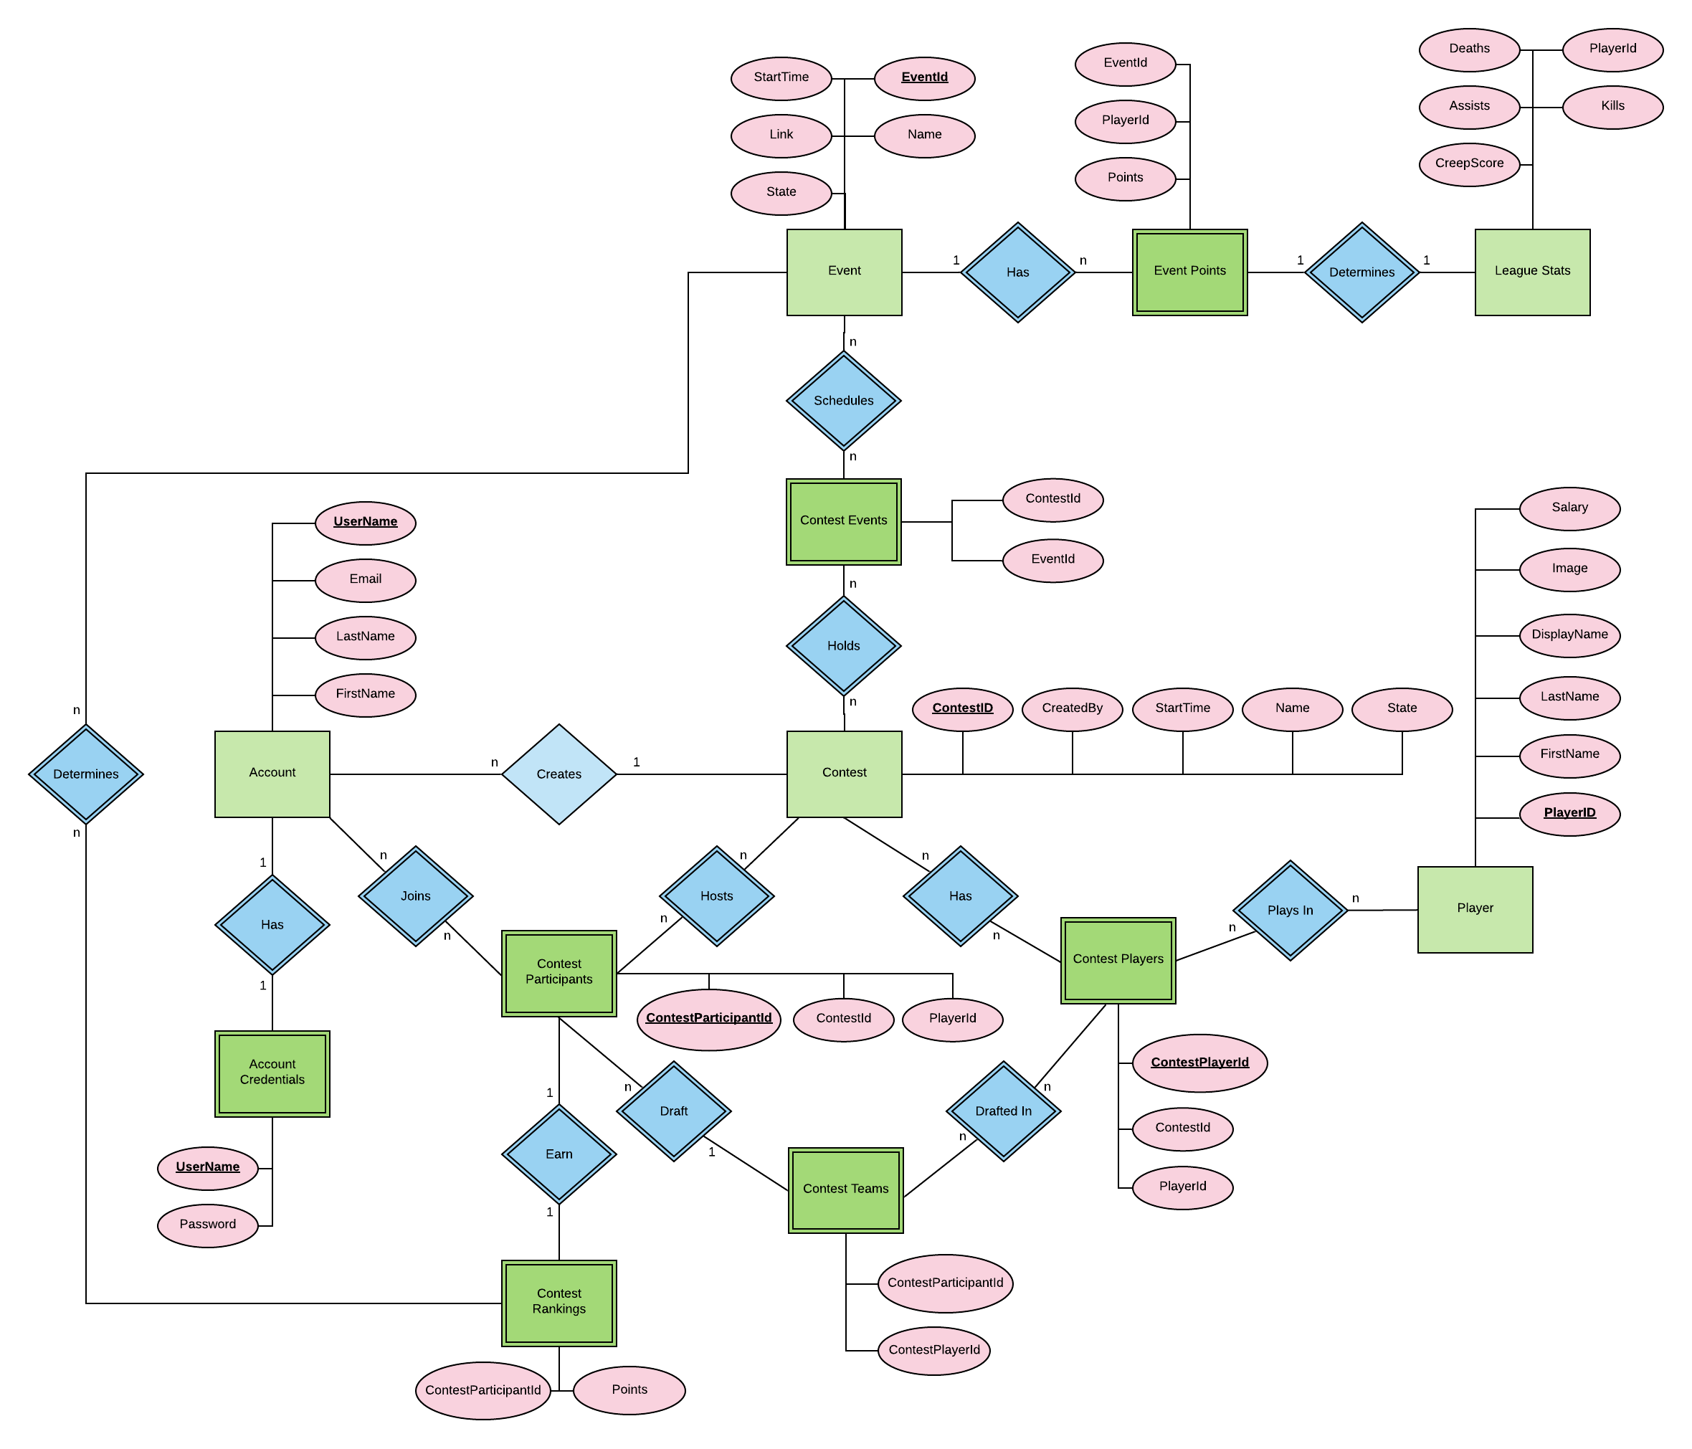

[Wireframe Model](https://xd.adobe.com/view/783a9e56-a145-4dbe-70dd-eaeab9bec940-0e0b/screen/2a0d5edc-c2ce-45bc-86a3-f327a88a4c18/Web-1920-1?fullscreen)

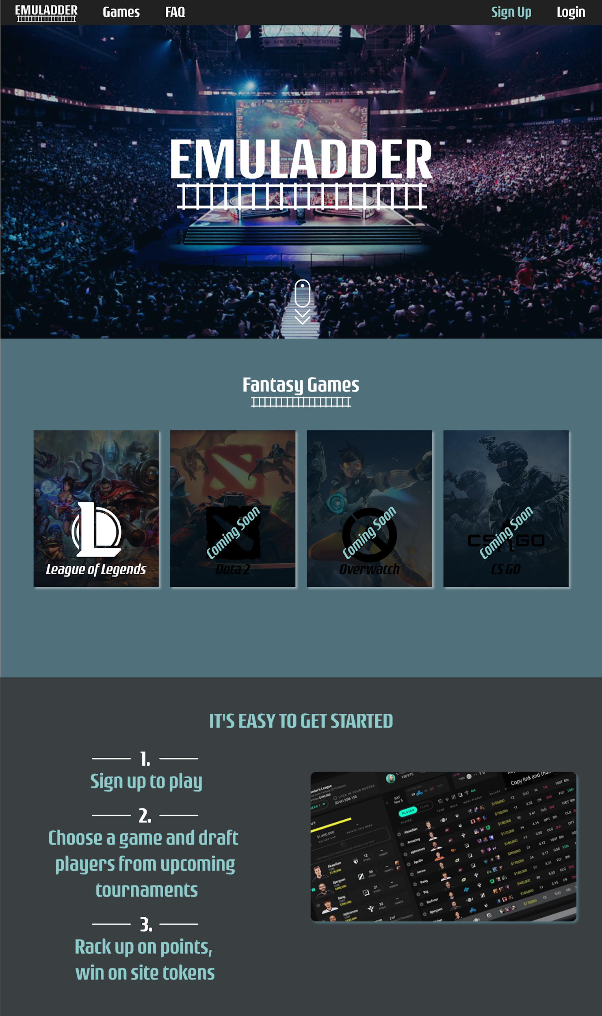

Above is the landing page of the web application which gives a general overview of what it takes to get started and pathing to the rest of the application.

Above the have the Login and Sign Up Screens the user can access by clicking either Login or Sign Up on the home screen of the application.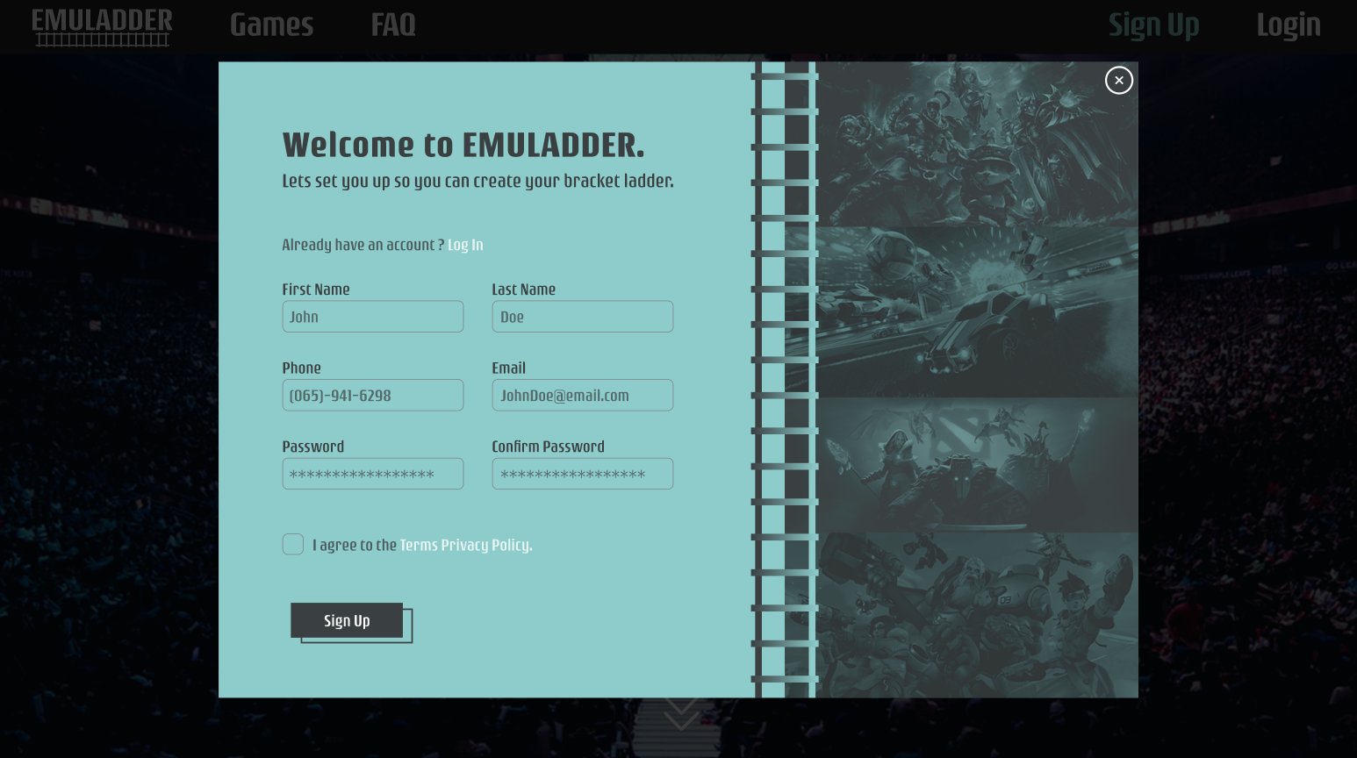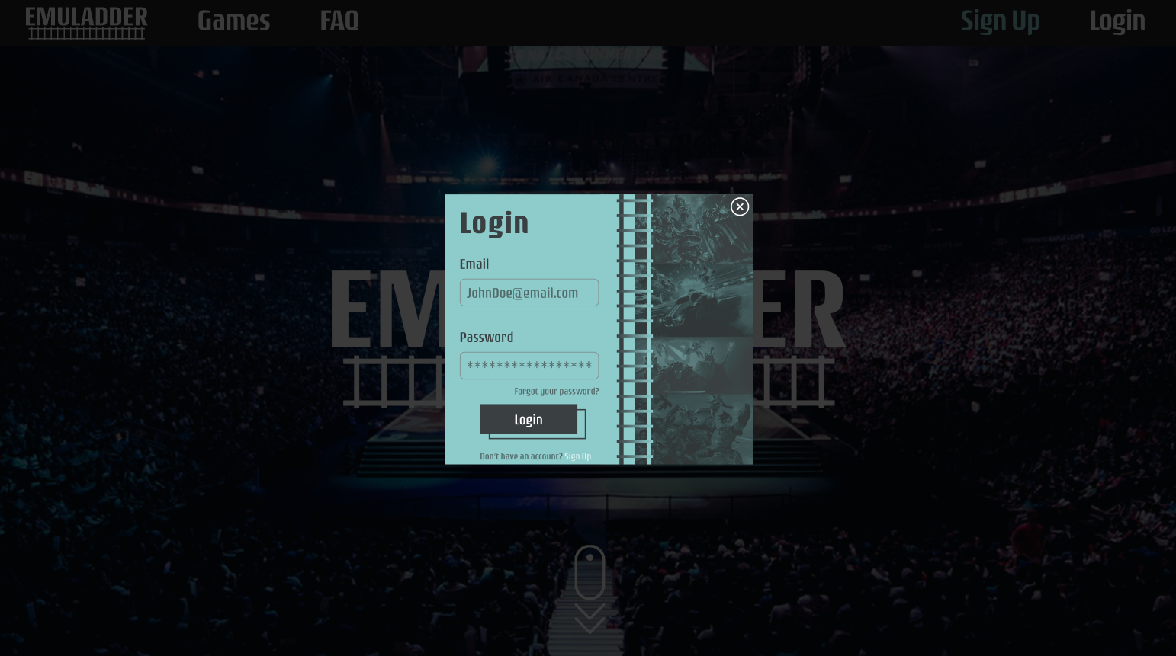

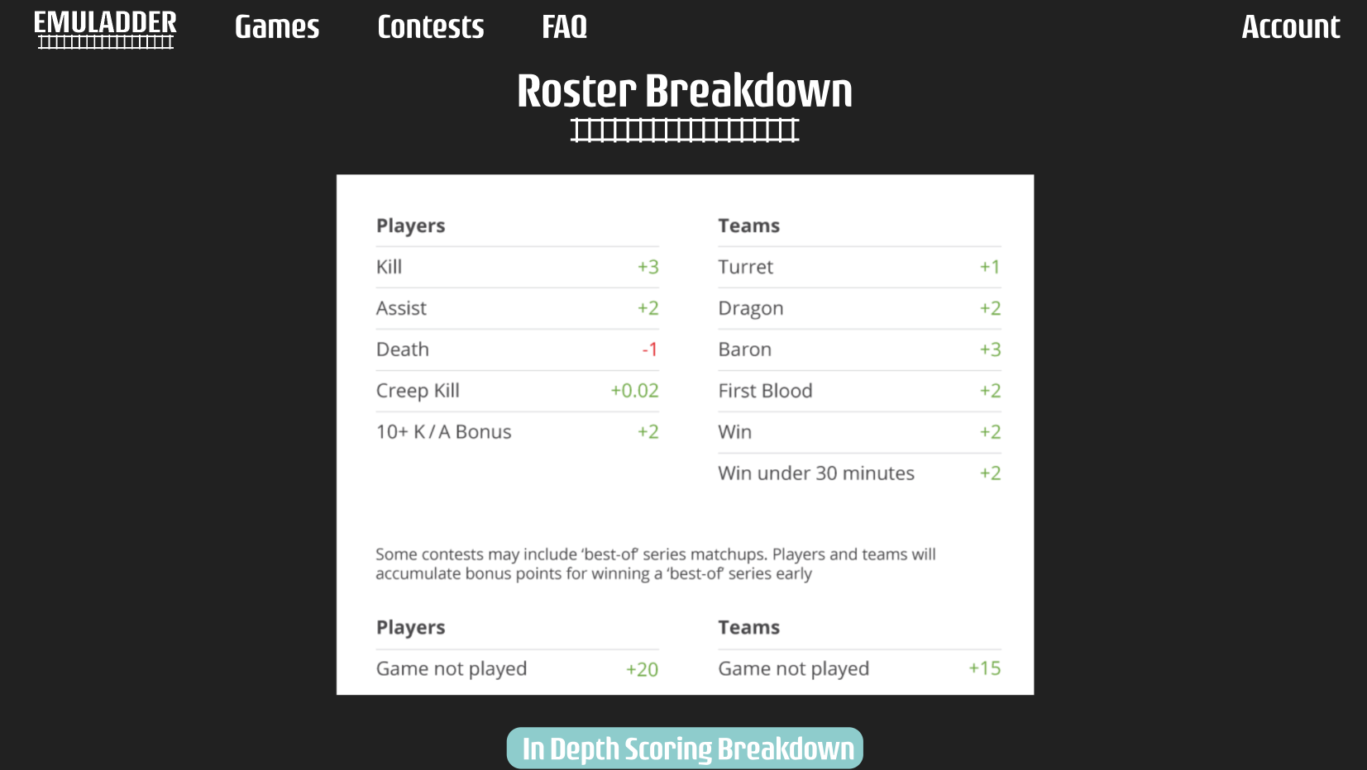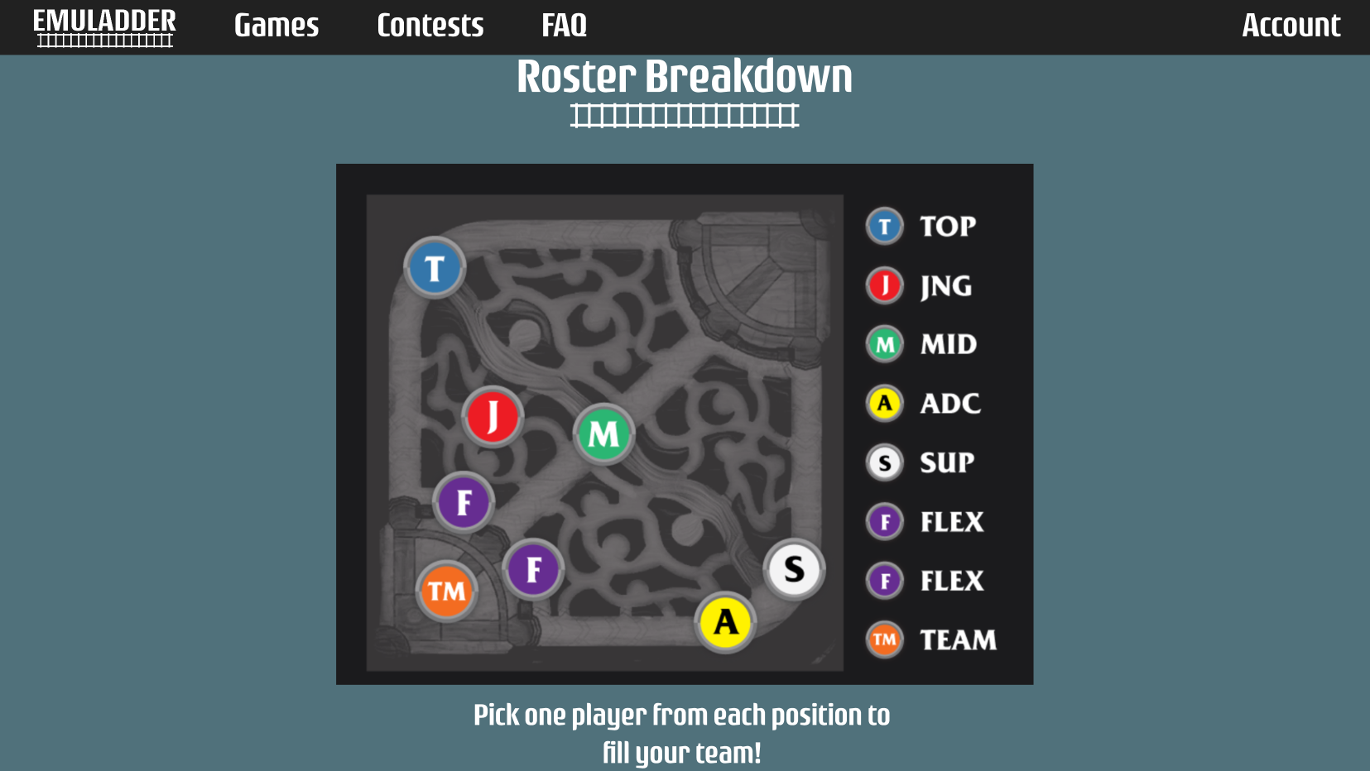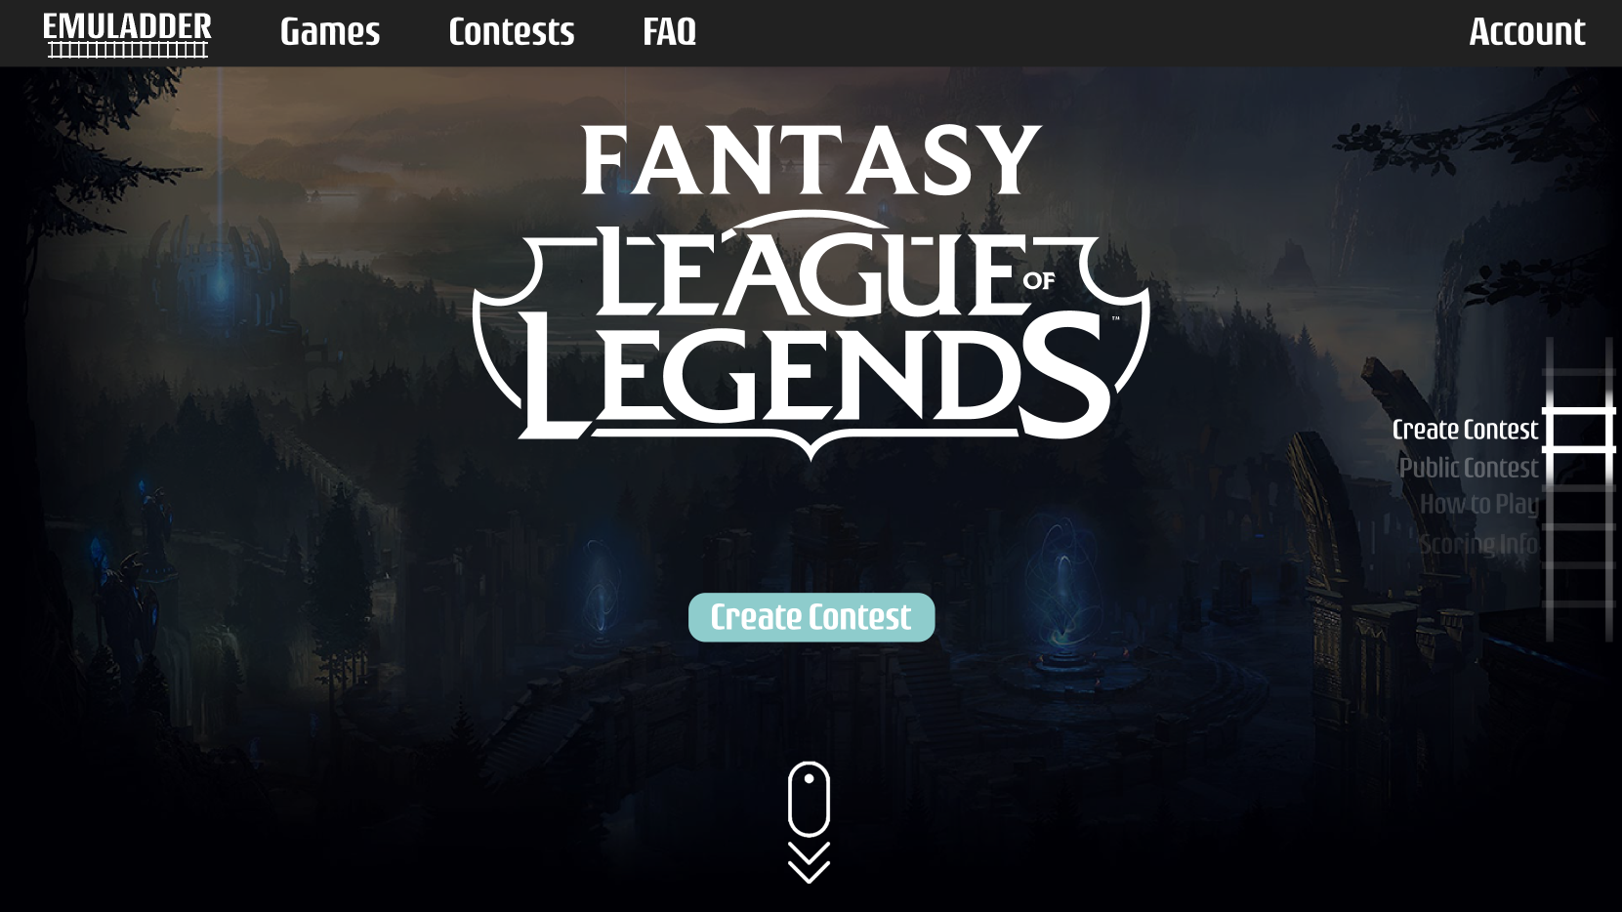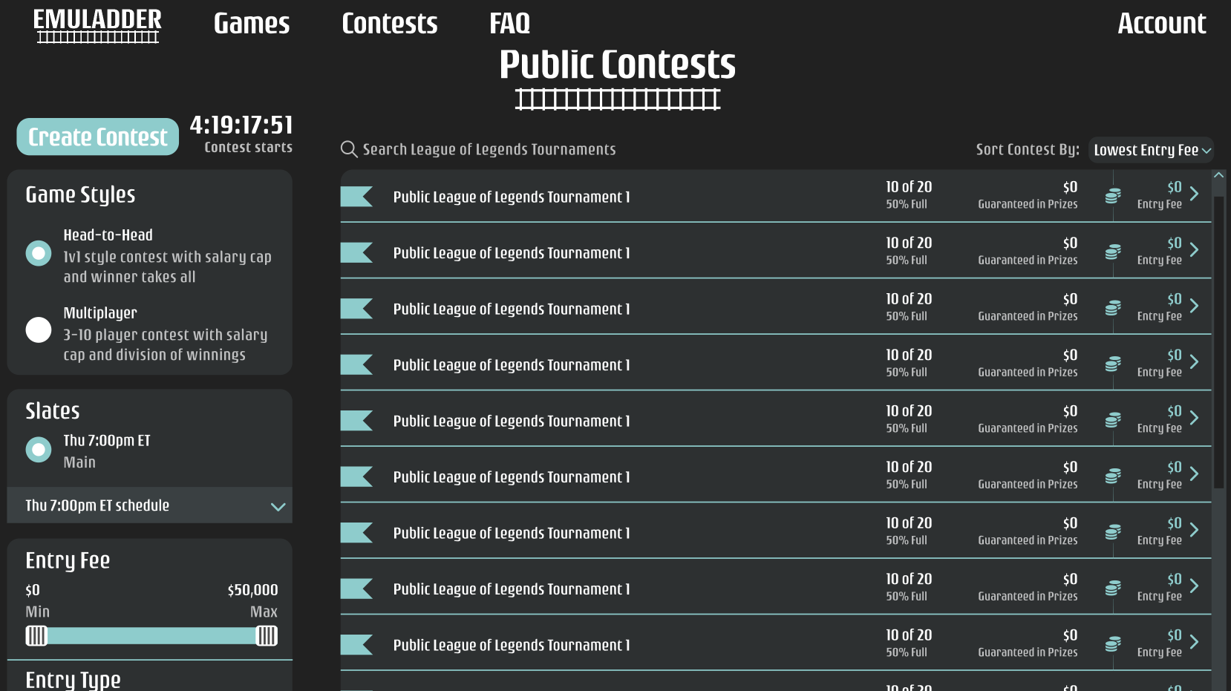

The above is the main contest landing page for League of Legends which allows the user to see public contests and information about how to play.

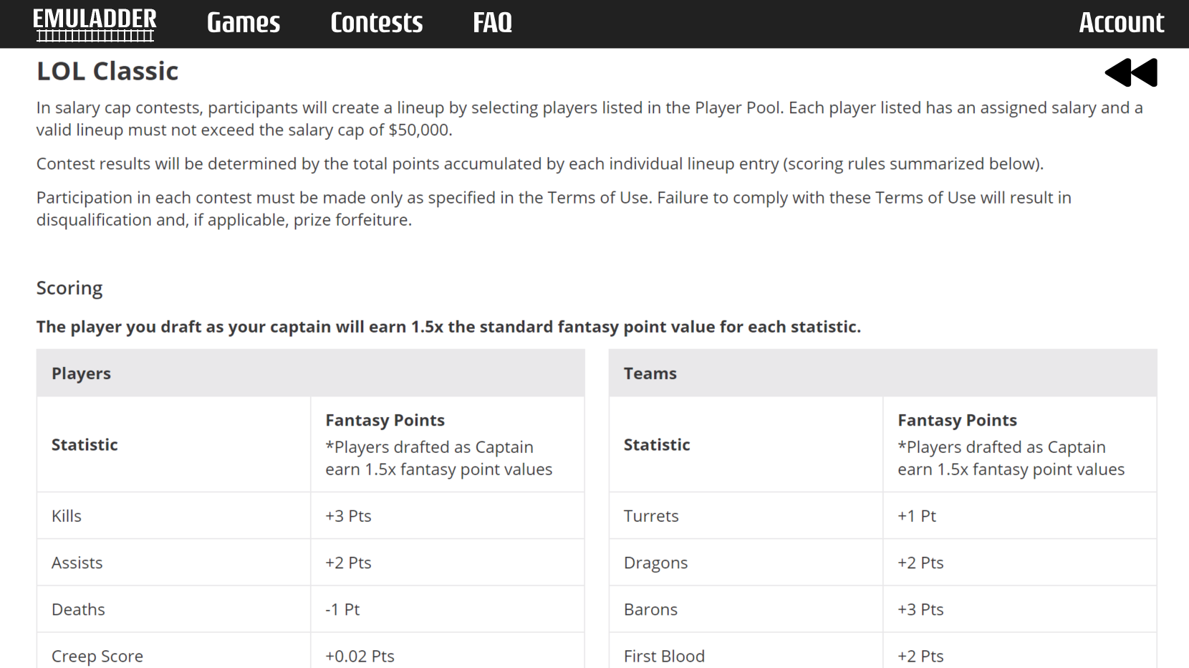

On the main contest page we link to an in depth breakdown of the scoring and rules for said contest if the user wants to know absolutely everything behind the scene. This document fills up a few pages and above is just the heading screen capture.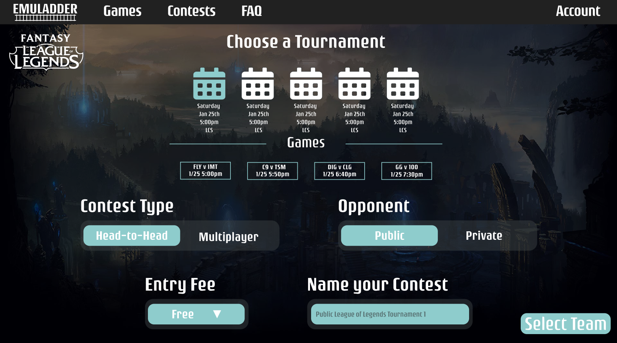

Above is the first step in contest creation after the “Create Contest” button is clicked. The user is presented with a schedule of events and controls for how the contest should be managed.

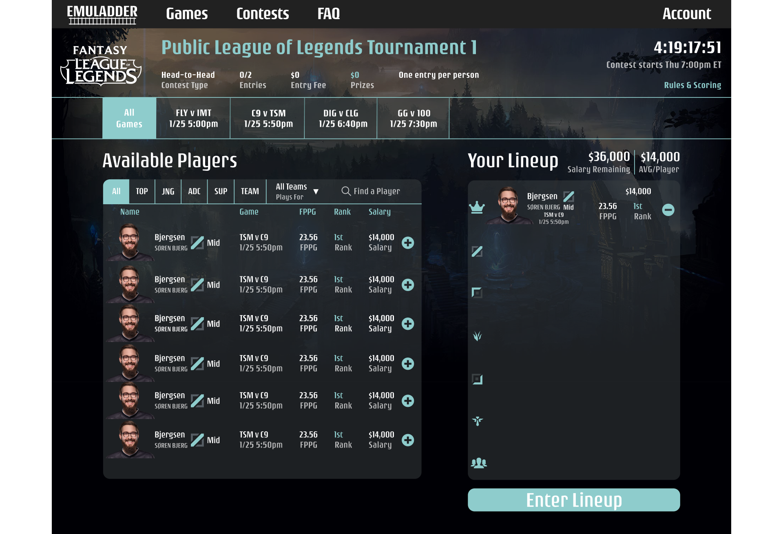

Once the user clicks “Select Team” they are sent to the drafting phase of the application in which the user picks their team via a plethora of sorting / filter options. The goal here is to draft the best team while staying under the salary cap.

Once the user enters their lineup they can then proceed to the invite page in which they can then add their friends to the contest.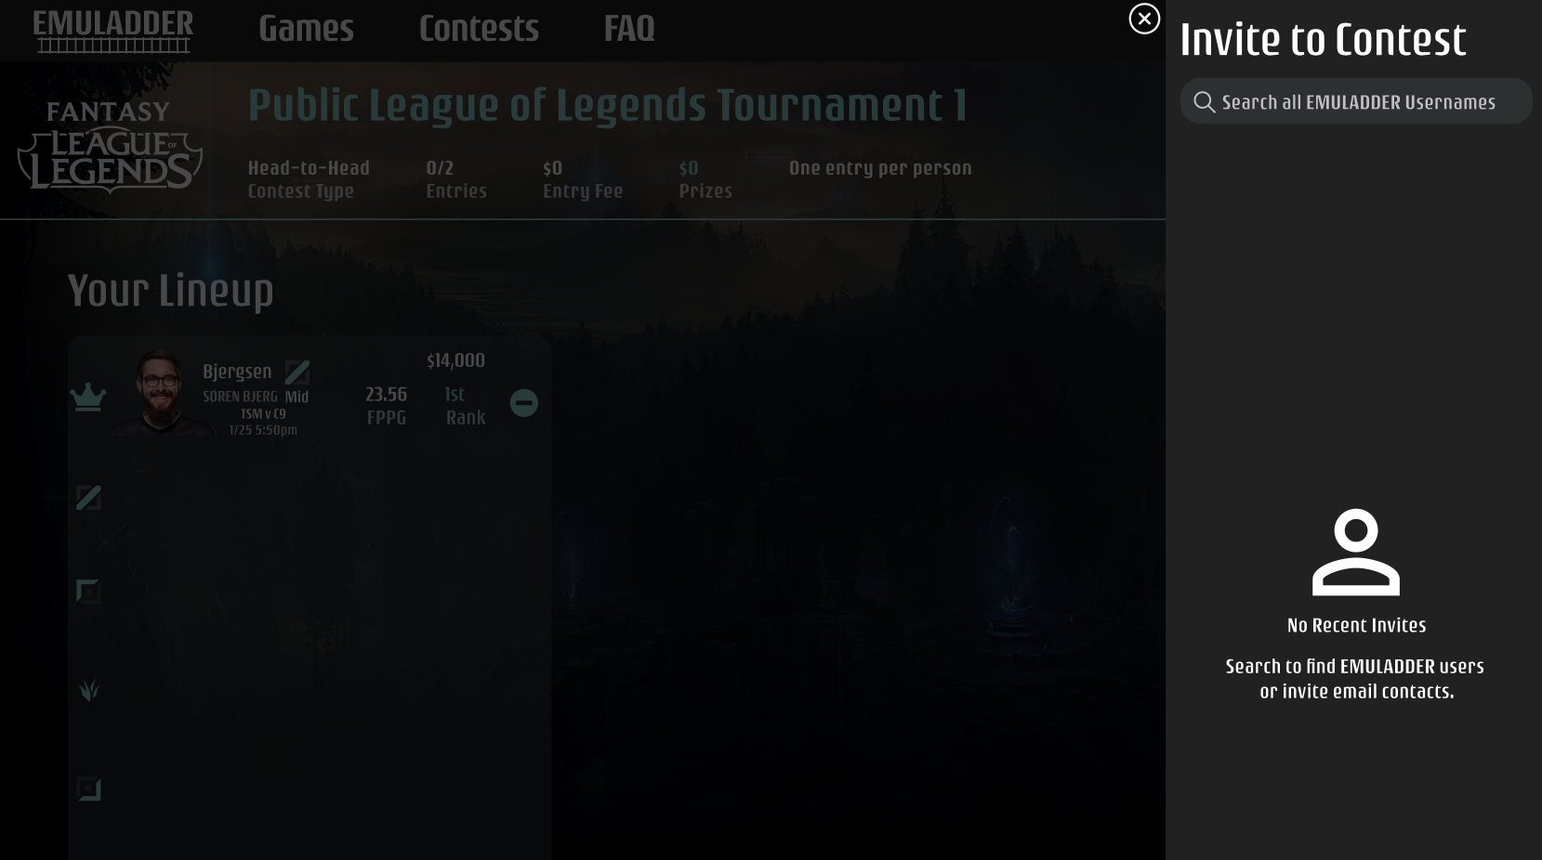

The contest page can be accessed from anywhere within the application as long as the user is logged in and will display the current contests the user has going on. 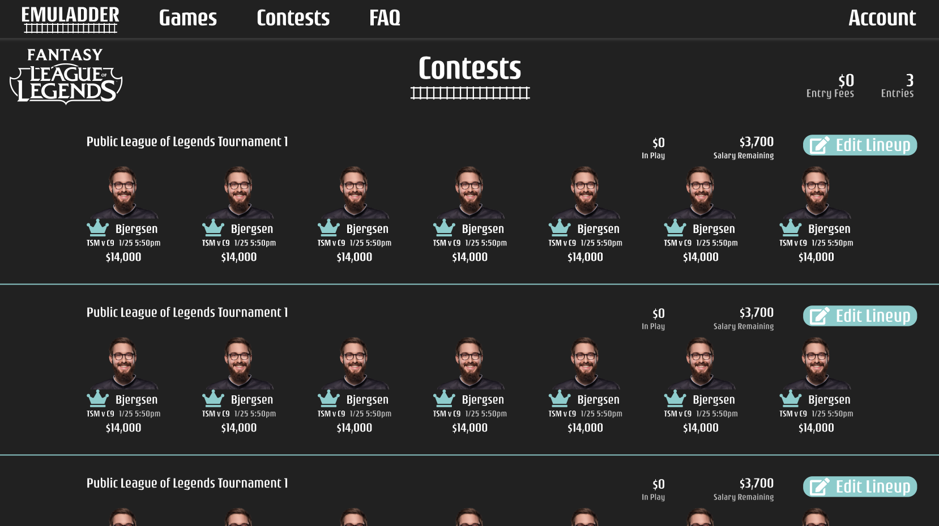

System - Analysis Perspective

Data Dictionary

|  |  |  |  |  |  |
| --- | --- | --- | --- | --- | --- |
| **Table** | **Column** | **Type** | **Description** | **References** | **PK** |
| Account | FirstName | Text | the first name of the user |  |  |
| Account | LastName | Text | the last name of the user |  |  |
| Account | UserName | Text | the unique ID of the user |  | Y |
| Account | Email | Text | the email used for communication with the user |  |  |
| Account Credentials | User Name | Text | the unique ID of the user | Account (UserName) | Y |
| Account Credentials | Password | Text | the password used for user sign in |  |  |
| Player | PlayerId | Integer | the unique ID of the player |  | Y |
| Player | FirstName | Text | the first name of the player |  |  |
| Player | LastName | Text | the last name of the player |  |  |
| Player | DisplayName | Text | the "gamertag" or nickname the player goes by |  |  |
| Player | Image | Text | the name of the player profile image |  |  |
| Player | Salary | Integer | the amount the player costs to be drafted |  |  |
| Contest | ContestId | Integer | the unique ID of the contest |  | Y |
| Contest | CreatedBy | Text | the user name of the user who created the contest | Account (UserName) |  |
| Contest | StartTime | Date / Time | the day and time the contest starts |  |  |
| Contest | Name | Text | The name of the contest |  |  |
| Contest | State | Integer | whether the contest has not started (1), in progress (2), or finished (3) |  |  |
| Contest Participants | Contest ParticipantId | Integer | the unique ID for the combination of contest and user |  | Y |
| Contest Participants | ContestId | Integer | the unique ID of the contest | Contest (ContestId) |  |
| Contest Participants | UserName | Text | the unique ID of the user | Account (UserName) |  |
| Contest Players | Contest PlayerId | Integer | the unique ID for the combination of contest and player |  | Y |
| Contest Players | ContestId | Integer | the unique ID of the contest | Contest (ContestId) |  |
| Contest Players | PlayerId | Integer | the unique ID of the player | Player (PlayerId) |  |
| Contest Rankings | Contest ParticipantId | Integer | the unique ID for the combination of contest and user | ContestParticipants (ContestParticipantId) | Y |
| Contest Rankings | Points | Integer | the number of points that determines the ranking of the users |  |  |
| Contest Teams | Contest ParticipantId | Integer | the unique ID for the combination of contest and user | ContestParticipants (ContestParticipantId) |  |
| Contest Teams | Contest PlayerId | Integer | the unique ID for the combination of contest and player | ContestPlayers (ContestPlayerId) |  |
| Contest Events | ContestId | Integer | the unique ID of the contest | Contest (ContestId) |  |
| Contest Events | EventId | Integer | the unique ID of the event | Events (EventId) |  |
| Event | EventId | Integer | the unique ID of the event |  | Y |
| Event | Name | Text | the name of the event |  |  |
| Event | StartTime | Date / Time | the day and time the event starts |  |  |
| Event | Link | Text | the url where the event can be viewed |  |  |
| Event | State | Integer | whether the event has not started (1), in progress (2), or finished (3) |  |  |
| Event Points | EventId | Integer | the unique ID of the event | Events (EventId) |  |
| Event Points | PlayerId | Integer | the unique ID of the player | Player (PlayerId) |  |
| Event Points | Points | Integer | the number of points the player achieved during the event |  |  |
| League Stats | PlayerId | Integer | the unique ID of the player | Player (PlayerId) |  |
| League Stats | Kills | Integer | the number of kills the player achieved |  |  |
| League Stats | Deaths | Integer | the number of deaths the player achieved |  |  |
| League Stats | Assists | Integer | the number of assists the player achieved |  |  |
| League Stats | CreepScore | Integer | the creepscore the player achieved |  |  |

Process Model:

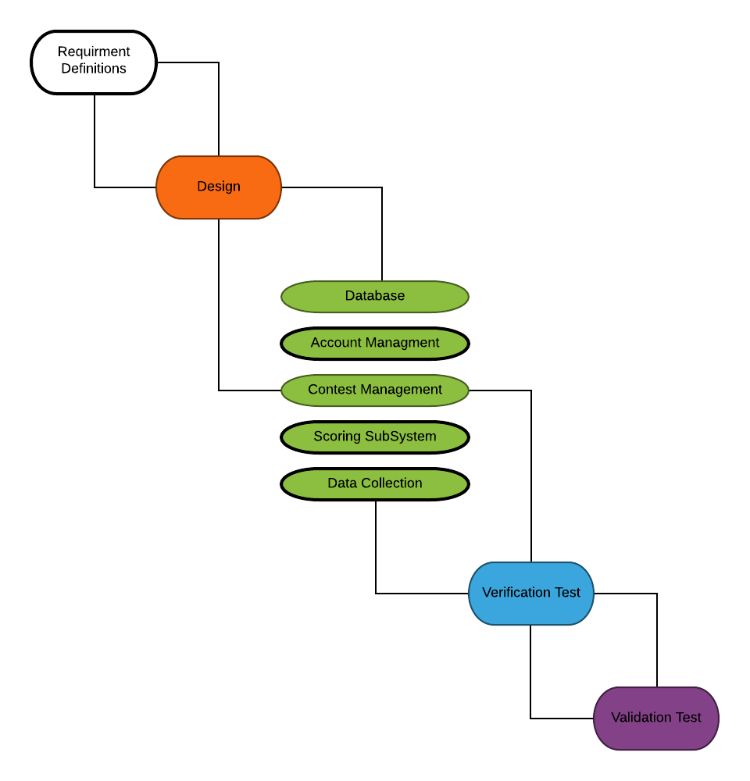

**Process model:**

The above model describes the current plan of how the system stages will be developed. In this model, we are showing that the subsystems will be developed in tandem.

System and Subsystem Algorithm Analysis

**Subsystems**

**Scoring O(n):** Operations include adding all points up together for scores and adding points to ranking. Both operations are O(n), making the time complexity of the scoring subsystem O(n).

**Contest Management O(n):** Operations at O(1) time complexity include creating contests, modifying contests and inviting friends to contests. Operations at O(n) time complexity include adding players to a contest and drafting players. The combination of the operations gives the contest management subsystem a time complexity of O(n).

**Account Management O(1):** Operations include creating an account, logging into an account, editing an account, signing up for contests and account recovery. All operations in this subsystem are O(1) time complexity, giving the subsystem as a whole a time complexity of O(1).

**Data Collection O(n):** Operations include retrieving JSON from API, which runs at O(1) time complexity, and converting JSON to database object notation, which runs at O(n) time complexity. This gives the data collection subsystem a time complexity of O(n).

**Database O(n):** Operations at O(1) time complexity include creating, inserting, deleting, and getting information from the database. Operations at O(n) include updating the table for all users. The combination of these operations gives the database subsystem a time complexity of O(n).

**System**

**emuLadder O(n):** Based on the time complexity of all subsystems for the emuLadder system and the combination of these subsystems, the time complexity for emuLadder will be O(n).